Tableau Tips

1. Show missing dates (of other values) in a graph even if there is no associated data:  
   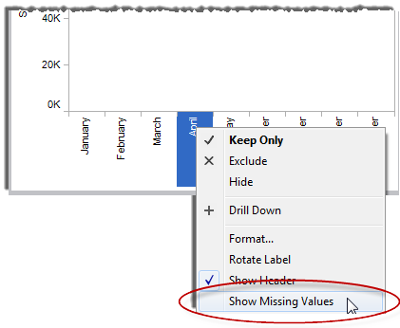
2. Add a total to stacked bars
   1. Right-click the continuous axis and select , Add Reference Line, Band, or Box.
   2. In the subsequent dialog box, select Line as the reference line type.
   3. Under Scope, select Per Cell.
   4. In the Line area, select a measure and an aggregation for the Value. In example, we'll use Sum(Sales) and SUM.
   5. Select to Label the line with the Value.
   6. In the Formatting area, change the Line to None.
   7. When finished, click OK.
3. Show only the TOP 10 items
   1. Create a calculated field to sort on  
      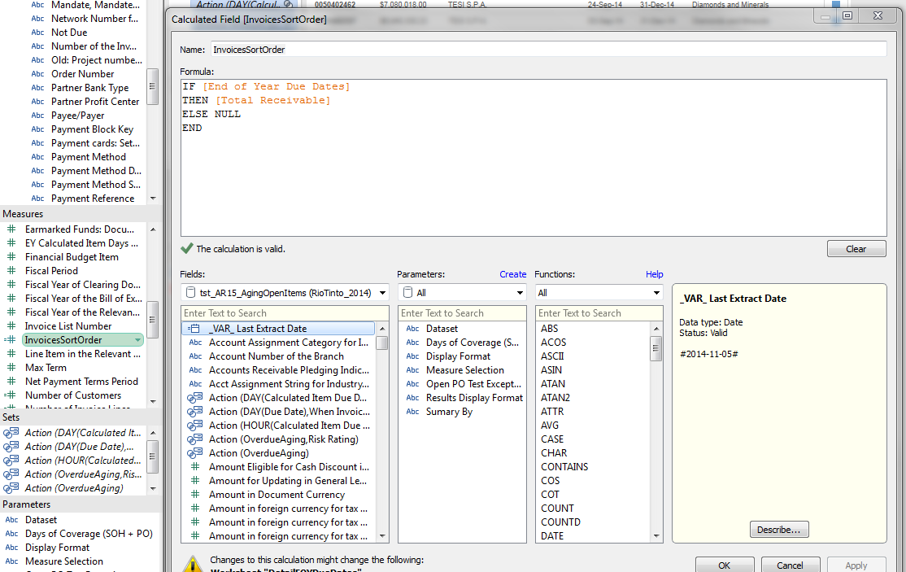
   2. Add a single field that you wish to filter by in the Filter shelf (Invoice Amount)  
      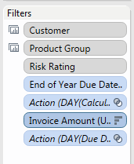
   3. Right click, Filter…  
      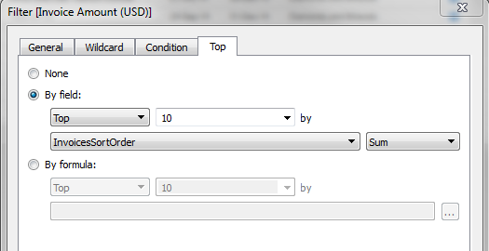
   4. Assuming we have parameter filters for the dashboard that this will be shown on, right click each and ‘Add to Context’. This forces the Top 10 to be the ‘Top 10 across each of these categories’ an when you filter, there will still be 10. If you don’t do this your Top 10 will be the top 10 of ALL items, and filtering may give you less than 10 in your list.
4. Refreshes aren’t bringing in the columns I added
   1. Save, Close, Reopen, Refresh.
   2. It caches the columns for some reason…
5. Renaming Axes

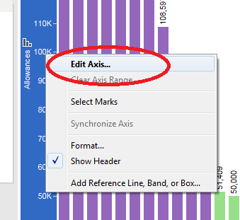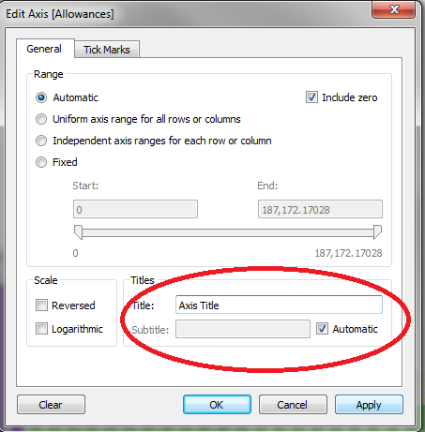

1. Adding a Total Bar

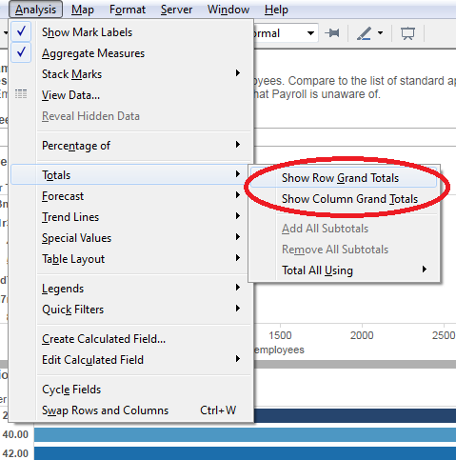 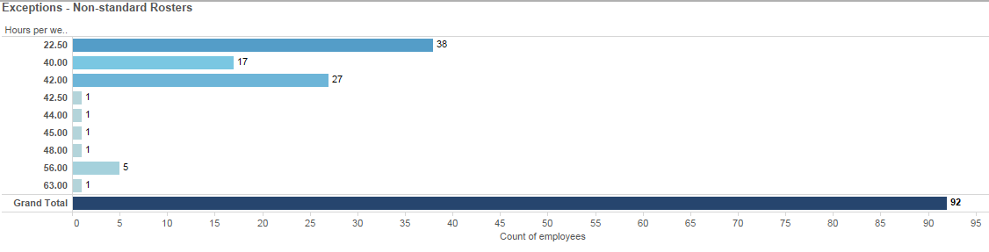

1. Grouping data into categories
   1. Choose your field to group on and define the ‘size’ of the categories. In this example we are grouping number of employees (using their Personnel numbers) and creating five buckets to allocate them too

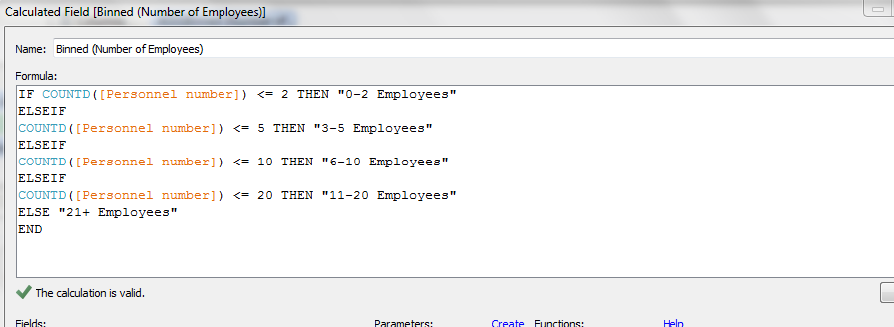

* 1. Assign this created field as a column then for the row assign a count of the category you are interested in. In this example we are interested in the organisational units – we can see there are 231 Org. Units with only 0-2 employees. Make sure you heavily label grouped graphs as they can be unintuitive at first glance

